**5. Final Report:**

* **Executive Summary:**
  + Summary of the project: This project is aimed to analyse customer data from a retail store to segment customers by considering various factors such as annual income and spending score/ purchasing behaviour. By identifying these segments, we can upskill the satisfaction and growth business by promoting the products to the customers who have high spending score. Using the dataset, we have done data cleaning, exploratory data analysis (EDA), K-Means clustering, and visualizations using matplotlib and Power BI.
  + Objectives: The primary objective of this project is to analyse customer data from a retail store and segment customers into various groups based on the purchase behaviour. By identifying these segments, the owner can make better marketing strategies to promote the products to customers groups on the basis of most purchased category of products which ultimately leads in the enhancement of engagement with customers and growth in sales.
  + Outcomes: Customer segmentation is a crucial aspect of customer relationship management (CRM) and marketing strategies. In the context of a retail store, understanding different segments of customers lead to:
    - Develop targeted marketing campaigns: Promote and advertise to specific customer groups on the basis of purchasing habits and category preference.
    - Personalise customer experience: Offering personalised recommendations and services to improve loyalty and customer engagement.
    - Optimise product offerings: Adjust inventory and product offerings to align with the different customer segments’ preferences.
    - Increase customer retention: Implementing strategies to retain high-value customers and reduce churn rates.
    - Enhance sales and revenue: Identify opportunities for cross-selling and up-selling to maximize sales and revenue.

By leveraging customer segmentation, the retail store can implement more effective marketing strategies, improve operational efficiency, and ultimately achieve a competitive advantage in the market.

* **Introduction:**

The primary objective of the project is to analyse customer data acquired from a retail store and segment customers into distinct groups based on their purchasing behaviour. By identifying these segments, the retail store can tailor its marketing strategies to meet the needs of each customer group, ultimately enhancing customer satisfaction and boosting sales.

Description of dataset: The dataset used for the analysis “Mall Customers” was retrieved from Kaggle. This dataset provides information about details customers of a mall. This contains demographic and behavioural attributes of the customers, which helps in the segmentation. The dataset includes:

1. Customer ID: A unique identifier for every customer.
2. Gender: A categorical attribute- Male/ Female
3. Age: Customer’s age
4. Annual Income (k$): Annual income of every customer in thousands of dollars.
5. Spending Score (1-100): Spending score of the customers describes the purchasing behaviour of the customer which was awarded by the mall based on the purchases made by the customer.

**Dataset**:

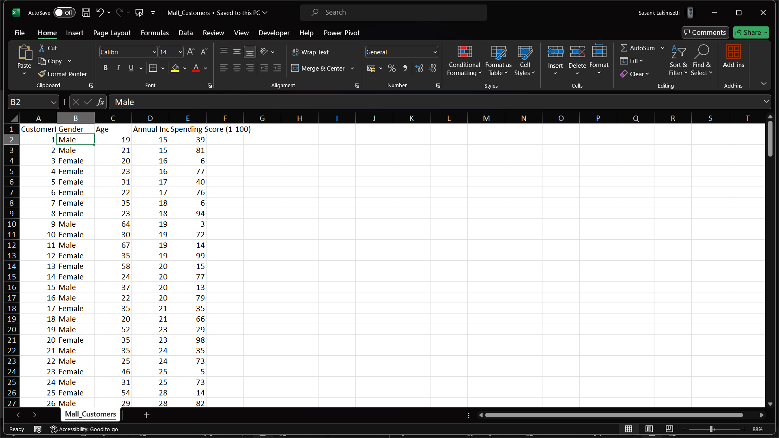

This dataset contains 200 rows and 5 columns in total.

**Purpose of dataset:** The dataset helps in performing customer segmentation analysis. By examining the demographic and behavioural attributes of the customers, we aim to identify distinct groups of customers who have similar purchasing behaviours. These insights let the retail store to develop targeted marketing strategies and enhance overall customer satisfaction.

**Data analysis and segmentation:**

1. Clean the data to handle missing values and inconsistencies.
2. Perform Exploratory data analysis (EDA) to understand the distribution and relationships within the data.
3. Apply K-Means clustering to segment customers into distinct groups.
4. Visualize the results using matplotlib and Power BI to gain actionable insights.

* Methodology:
  + Data Collection: We used the "Mall Customers" dataset, which contains demographic and behavioural attributes of customers such as Customer ID, Gender, Age, Annual income, and spending score.
  + Data Cleaning: Handled missing values and ensured data consistency.
  + Exploratory data analysis (EDA): Performed EDA to understand the distributions and relationships within the dataset.
  + Clustering analysis: Applied K-Means clustering to segment customers into distinct groups.
  + Visualization: Used matplotlib and Power BI to visualize the results and gain actionable insights.
* Results:
  + Analysis of age, gender, annual income, and spending score provided insights into customer demographics.
  + K-Means clustering identified customer segments based on purchasing behaviour.
  + Power BI visualizations highlighted the distribution and characteristics of each customer segment which gives a clear picture of the analysis.
* Conclusion:
  + Targeted marketing: Making promotions and advertisements to specific customer groups depending on their purchasing habits and preferences.
  + Personalize customer experiences: Offer personalized recommendations and services to improve customer satisfaction and loyalty.
  + Increase retention of customers: Implement strategies to retain high-value customers and reduce churn rates.
  + Enhance sales and revenue: Identify opportunities for cross-selling and up-selling to maximize sales and revenue.

**Appendices:**

* Charts:

Visualizations using matplotlib

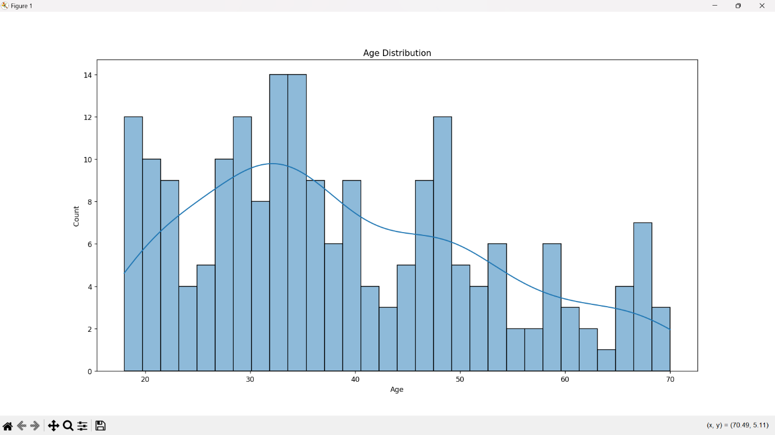

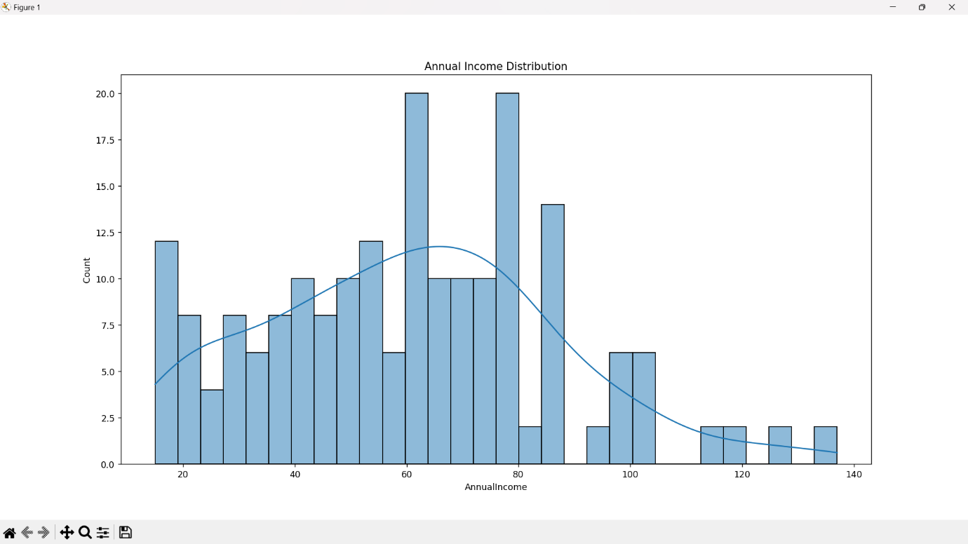

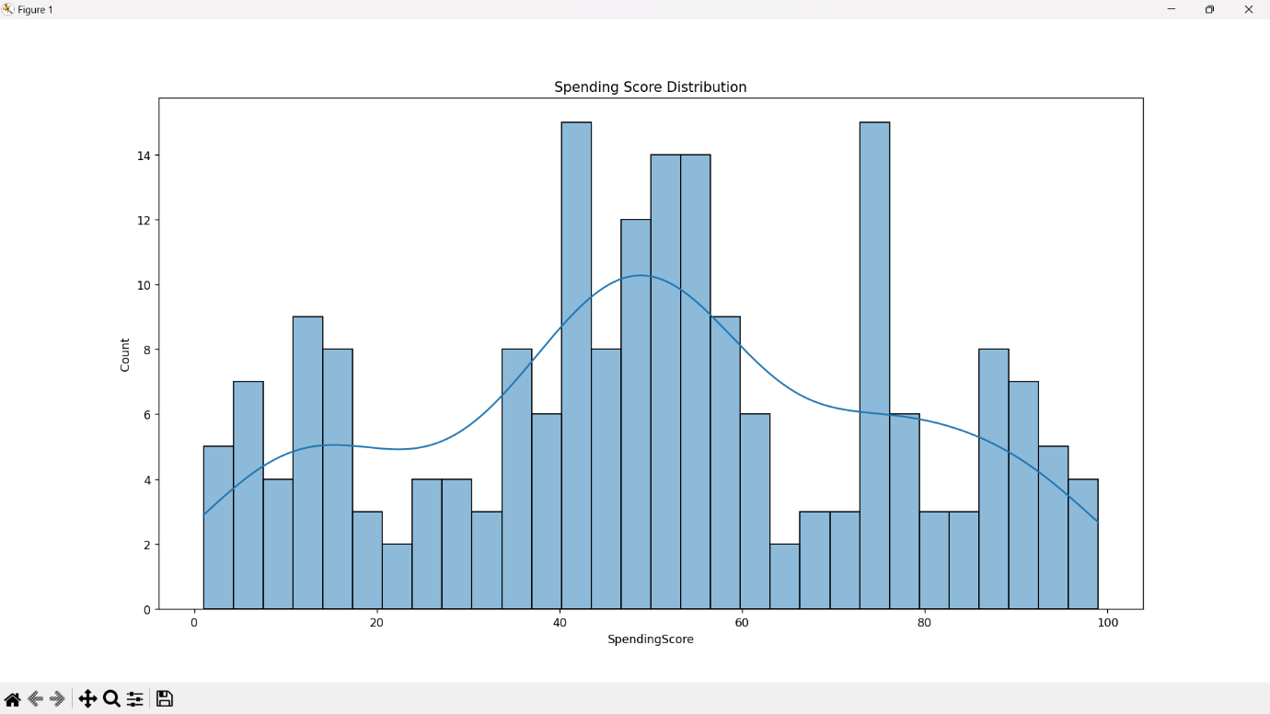

Visualizing Relationships

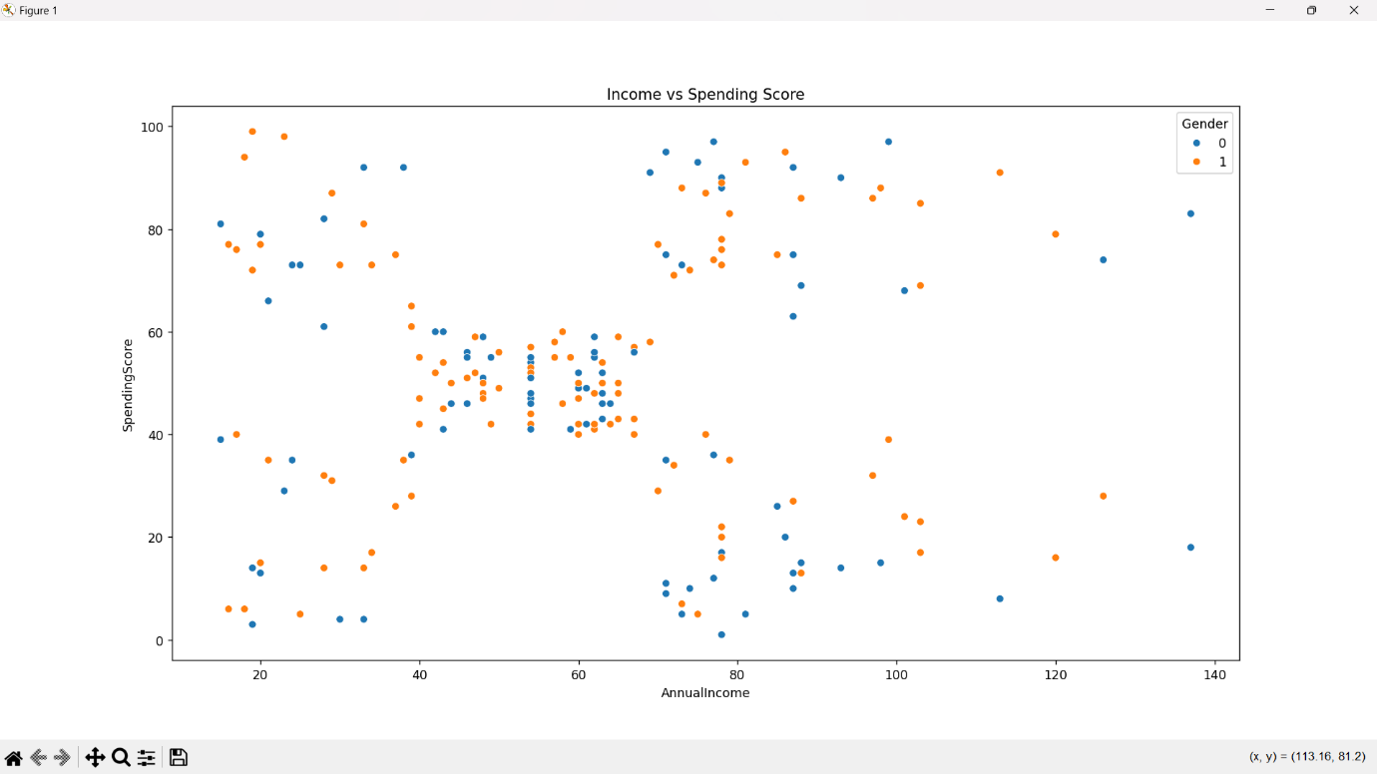

K-Means Clustering

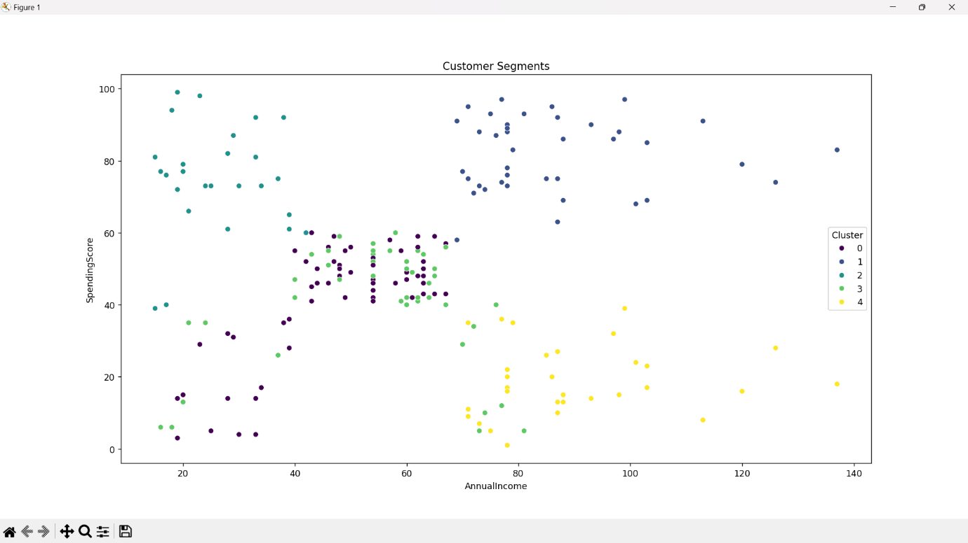

Visualisations using Power BI

Pie Charts:

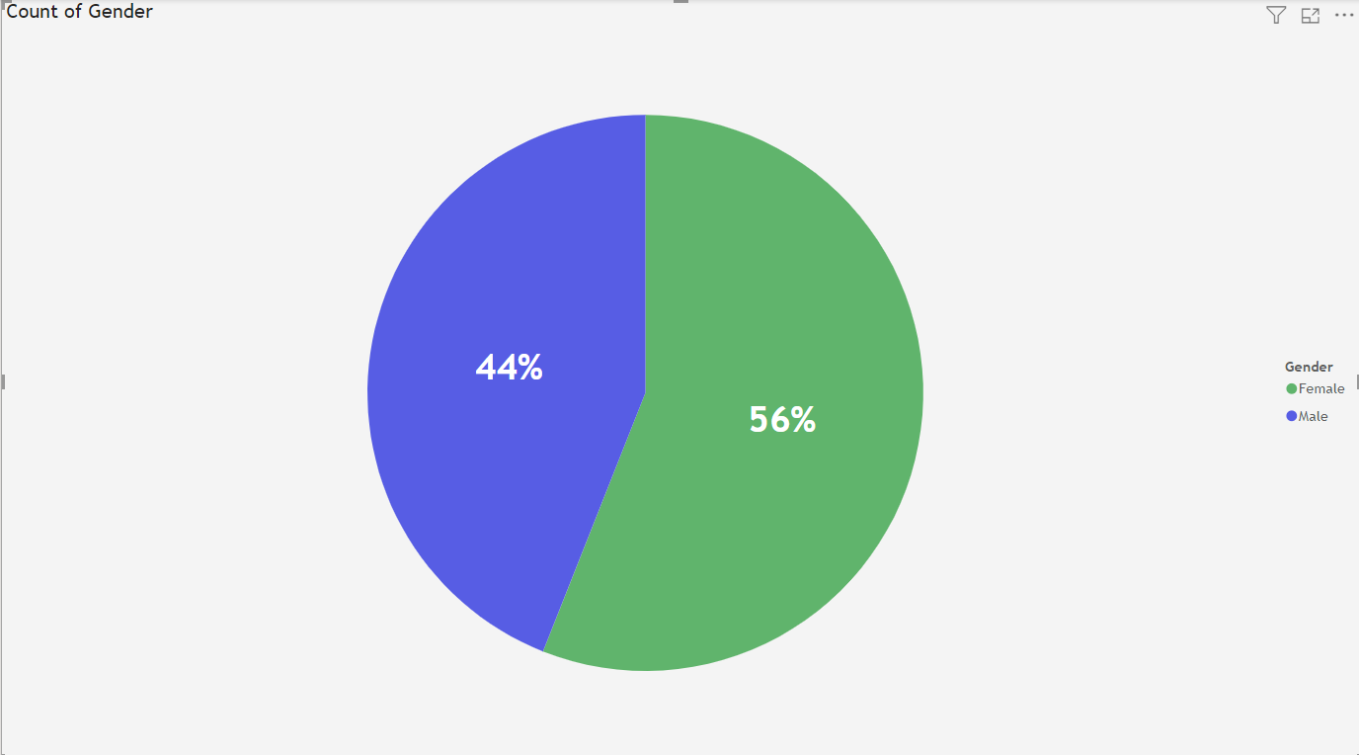

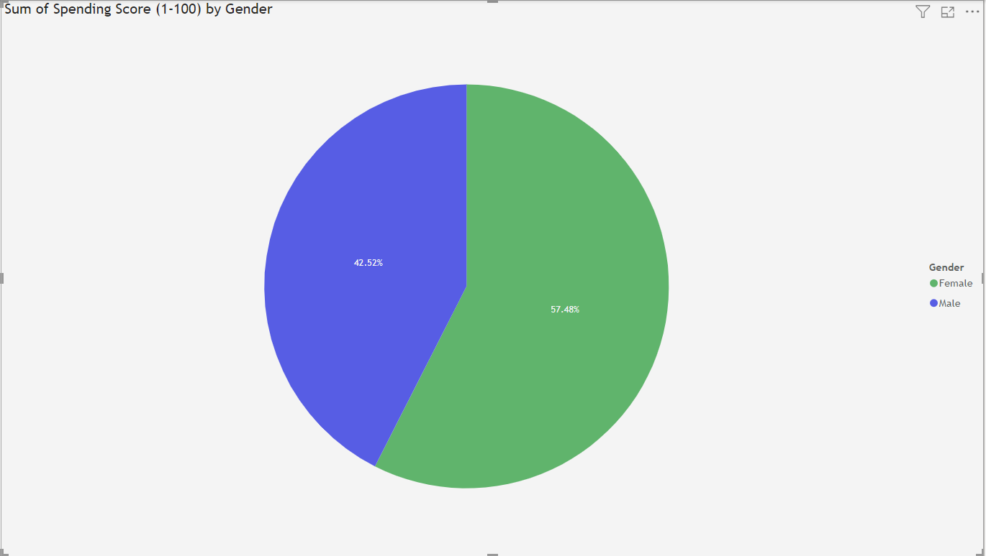

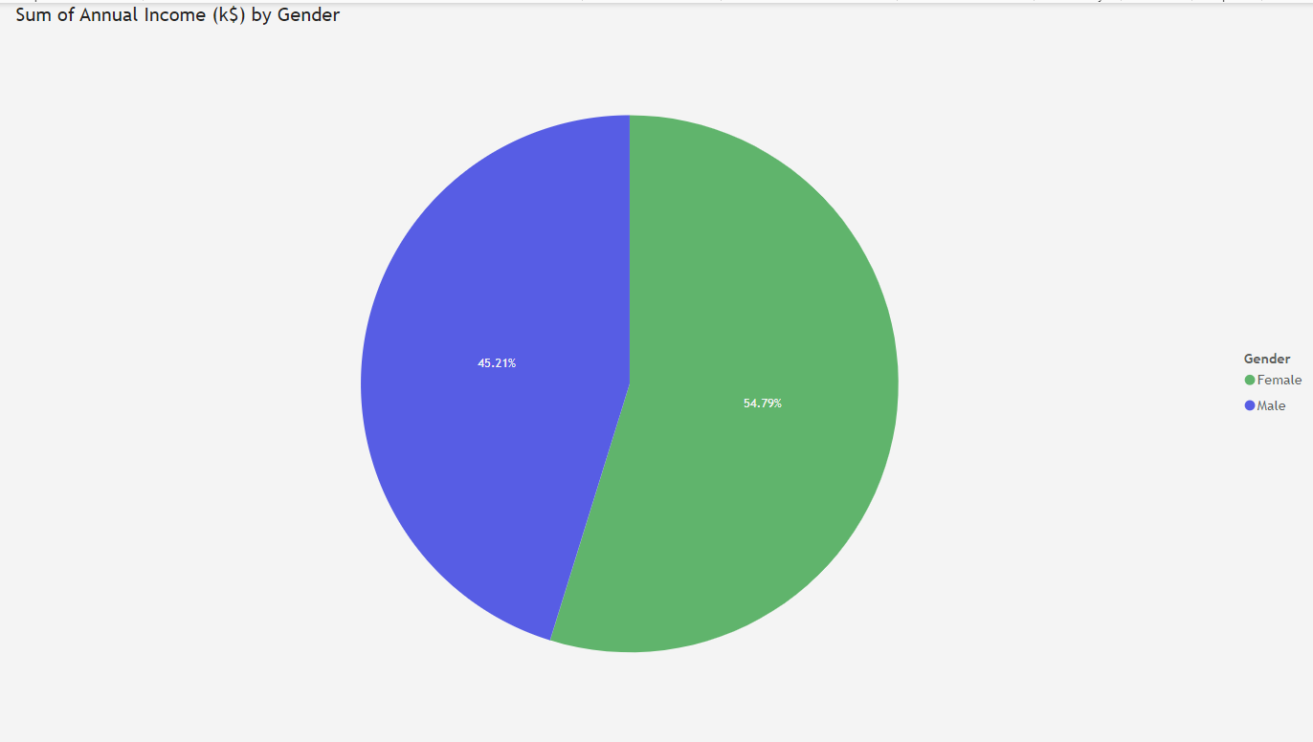

Clustered Column Chart:

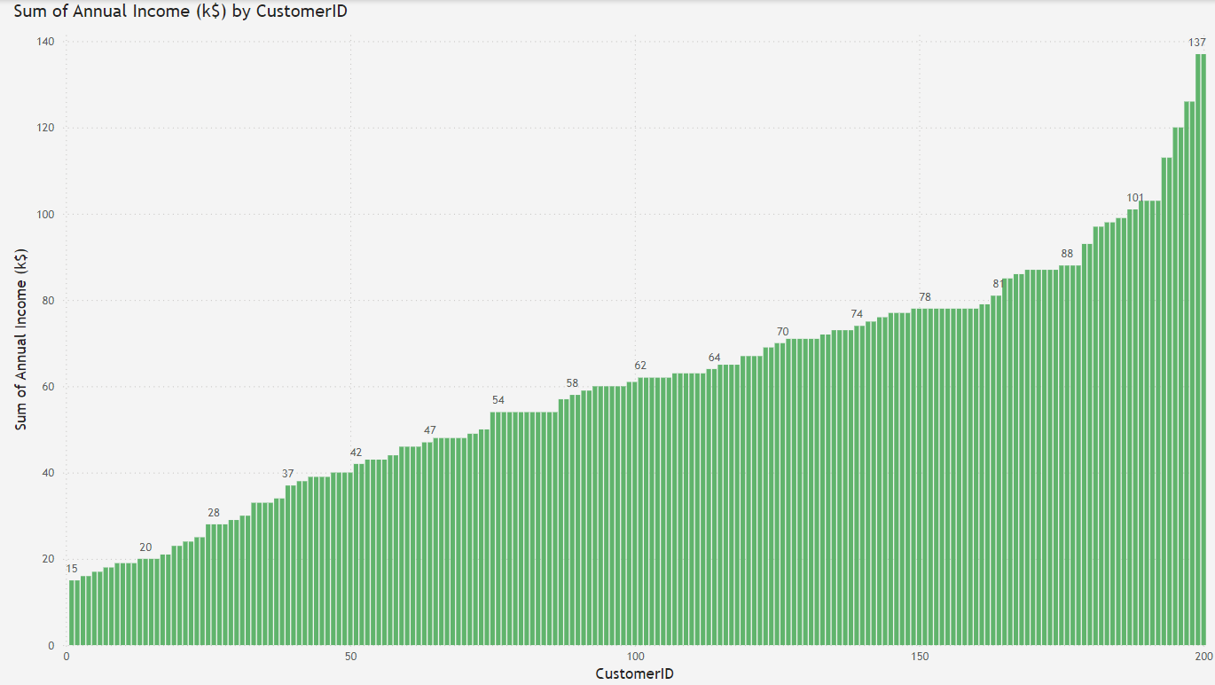

Line Graph:

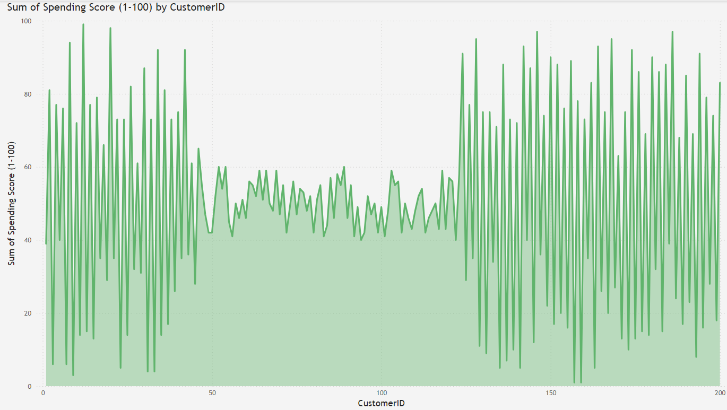

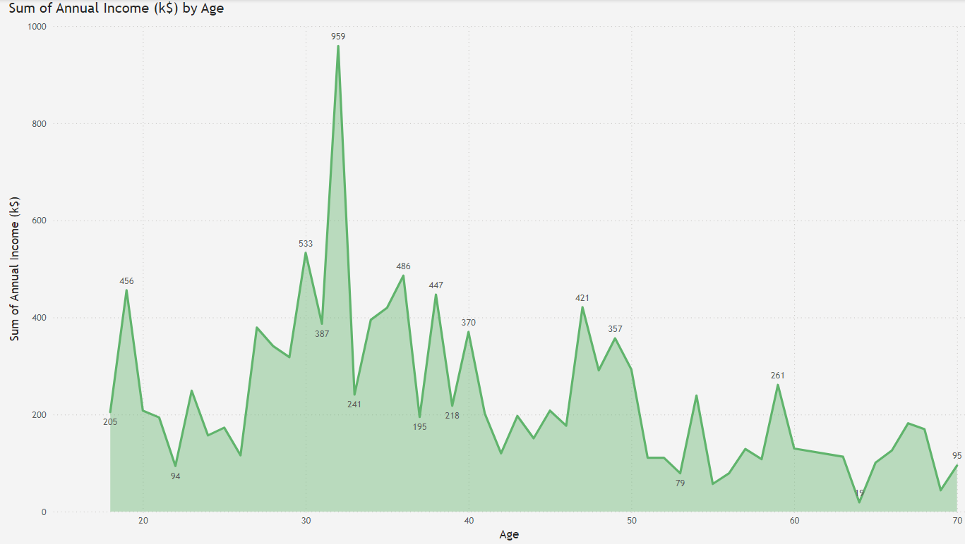

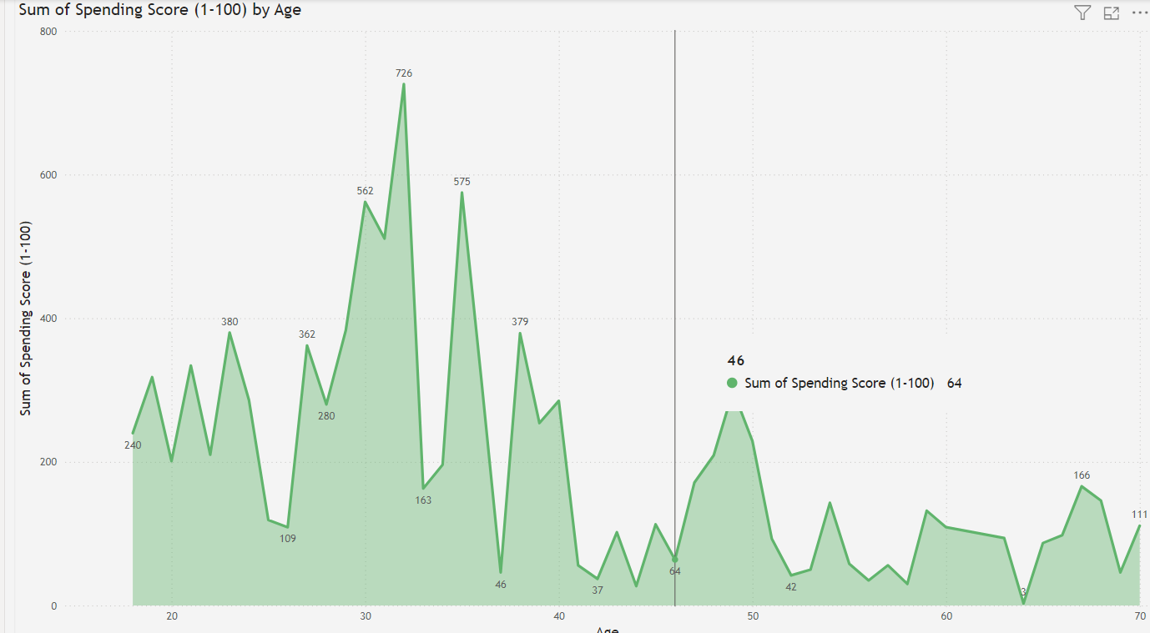

Dashboard:

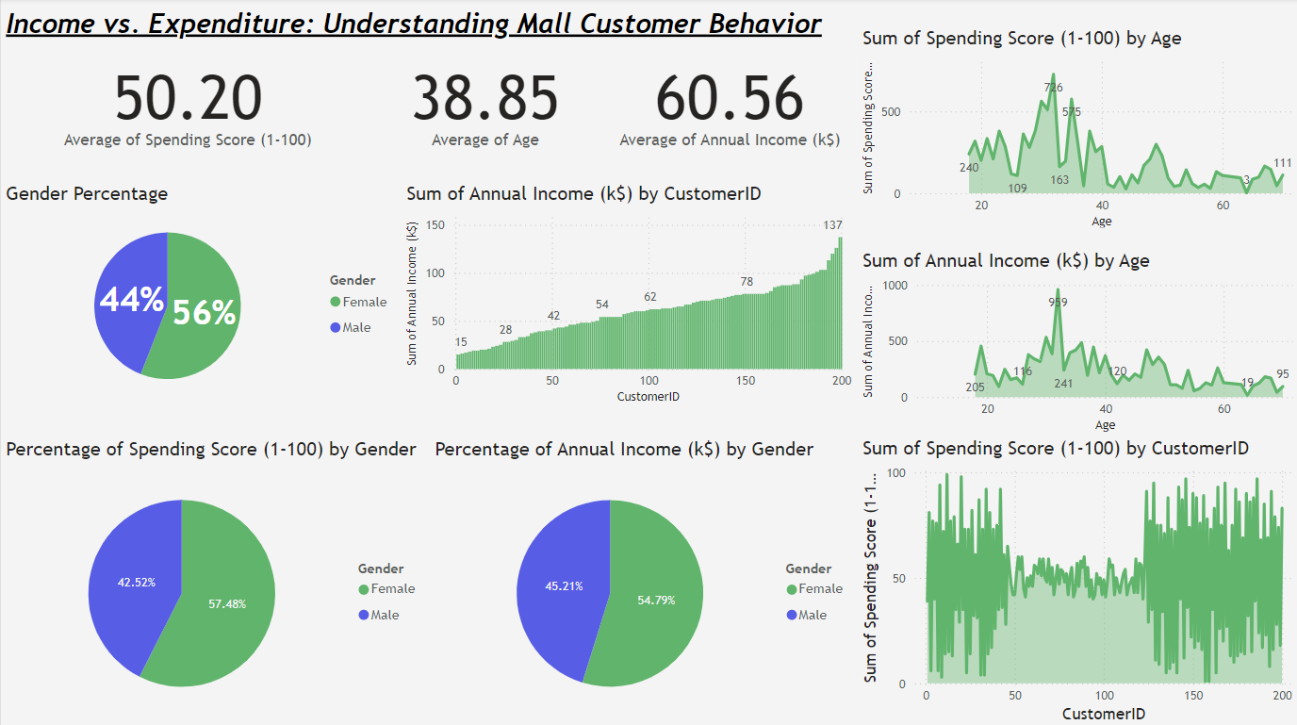

Code Snippets:

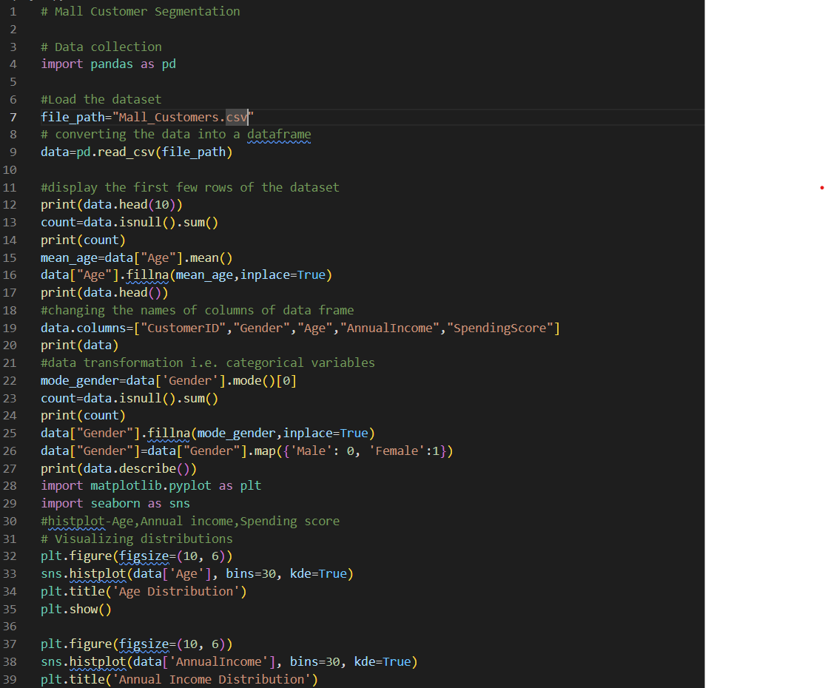

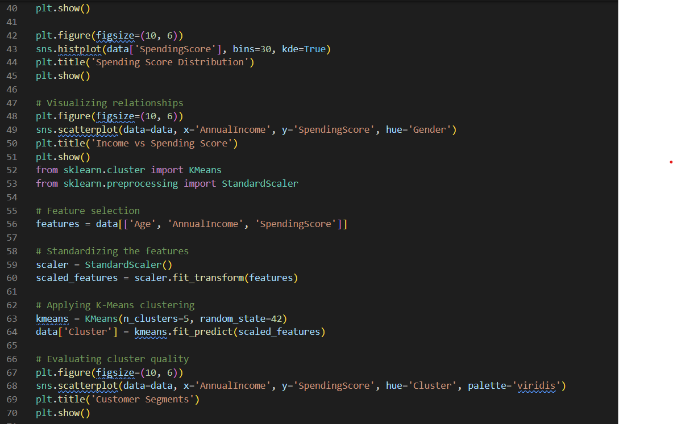

Dataset Reference: <https://www.kaggle.com/datasets/shwetabh123/mall-customers>